Tautra Mariakloster

Sr. Sheryl Frances Chen, OCSO

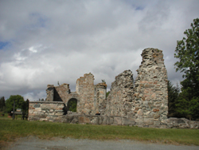
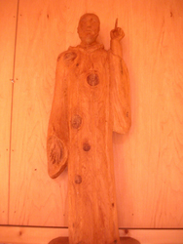
The first Tautra Mariakloster was dedicated March 25, 1207 by Cistercian monks. It was a solemn feastday, the Annunciation of the Lord, as it is called today. Some monks probably came from Munkeby in Levanger. Cistercians usually dedicate their monasteries to the Virgin Mary and the place. The monks called the monastery Sancta Maria de Tuta Insula, the Monastery of Our Lady of the safe island.
Only the church was built in soapstone and basalt. Some of the stones probably came from Leksvik and Munkholmen. The rest of the monastery was of wood, so only a few traces have been found in the ground east of the church. The ruins have been owned by the Society for the Preservation of Historical Landmarks since 1846.
The complex would not have supported more than 30 monks. They cultivated the earth, as well as trees and herbs. At its high point, Tautra was responsible for over 170 small farms, some of them as far away as Levanger. At the time of the monks, the fjord was 5 meters higher than it is today, so the monks had to row to their fish ponds which lie across from the new Mariakloster. In fact, Tautra was two islands then. When the glacier began to recede, the lack of the weight of ice caused the earth’s crust to rise about 60 mm a year. The land is still rising today, about 2 mm each year near the coast.
Monastic life weakened when royal and religious powers clashed during the Reformation. The monks were dispirited and poor at the end. The community dispersed in 1531 when
the monastery was sold to Nils Lykke. Tautra Mariakloster came into the possession of the crown in 1537.
Cistercian monks and nuns follow the Rule of St Benedict, written in the 6th century. The Cistercian order began in 1098 when some 20 Benedictine monks left Molesmes abbey in France. These monks, led by Robert, Alberic and Stephen, wanted to live according to a stricter interpretation of the Rule, and went to a wilderness called Cîteaux. The Latin for Cîteaux gives us the name Cistercians.
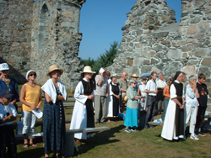
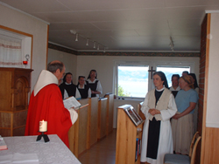
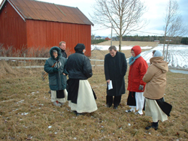
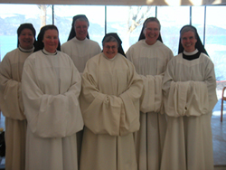
The new order struggled to establish itself until a young knight named Bernard knocked on the door in 1112. He was eager to be a monk, and brought with him thirty of his relatives. Bernard and Cistercian life fit like a hand in a glove, and he soon became famous as a preacher and the Cistercian order’s most talented spokesman ever. He was chosen to be abbot of Cîteaux’s third daughterhouse Clairvaux. He turned a valley of wormwood into “The Valley of Light.”
The Cistercian order grew incredibly quickly and strived to reach the ends of the earth. Clairvaux started Fountains Abbey in North Yorkshire, England in 1132. Fountains in turn established Lyse Kloster near Bergen in 1146. It was from here that monks came to Tautra in 1207 to begin monastery number 552 in the Cistercian order. This means that 552 new Cistercian monasteries were established in the course of the order’s first 109 years. Besides Lyse and Tautra, Hovedøya in the Oslo harbour was also Cistercian.
In 1974, a young Norwegian woman felt called to Cistercian monastic life. Ina Andressen entered Notre-Dame de La Coudre in Laval, France, and made solemn profession of vows there. Twenty years later, journalist Hanne Berentzen entered Wrentham Abbey in Massachusetts, USA.
Sister Ina obtained permission to come back to Norway to see if the time was right to re-establish Cistercian life. She was helped by Sr Marjoe Backhus of Mississippi Abbey in Iowa, USA. The then-mayor of Frosta, Jens Hagerup, invited them to live next to the ruins on Tautra. A support group started in Trondheim and promised to pray every day at 6:00 p.m. that the Cistercians would come back to Norway. After a year and a half, Sr Ina became seriously ill and had to return to France for treatment. It looked like the dream was ended.
Across the Atlantic, Mississippi Abbey increased in number such that the nuns had to decide whether to build an extension to their monastery, or start a new one. Bishops all over the world invited Mother Gail Fitzpatrick to their diocese, including Australia, Tunisia and Tautra. Bishop Georg Müller, the Catholic bishop of Trondheim, was very eager to bring Cistercian nuns to the Trondheim diocese. Though the nuns tried to buy property in Småland, a family home became available on Tautra at the last minute. The bishop purchased the site, together with the neighboring field where the permanent monastery would be built, and Mother Gail sent seven nuns to Tautra in February 1999.
Mother Rosemary Durcan was named superior. Under her leadership the nuns had to turn three small family dwellings into a monastery. They established the most important rooms of a monastery: first the chapel, then the refectory (dining room), chapter room (meeting room where a chapter of Benedict’s Rule is read each morning) and the scriptorium (reading room). This last they did not have room for, so they used their individual cells for spiritual reading. Some of the cells had to have several functions, for example sewing, wardrobe, liturgy office and passageway.
St Benedict encourages nuns who live according to his Rule to earn their living by the labor of their own hands. Sr GilKrist Lavigne had made herbal soap as a hobby at Mississippi Abbey. The nuns decided to try soap production as their main industry. One room in the red house was set aside as the soap factory. Everything that had to do with the business had to be done here: buying of ingredients, research and development, the making of soap itself, cutting and storing, wrapping and packing, billing and shipping. In 2001 a benefactor made it possible to build onto the red house. The addition housed three more cells and an extension of the soap factory on the ground floor.
The nuns began to plan the future permanent monastery in 2000. For 18 months they worked with architect Svein Skibnes until he had to resign. The nuns were very disappointed in this delay, but interpreted it as a sign that God wanted to use the time to create the real building which is the community. To have to listen to one another and respect different viewpoints demands that the values of the gospel be lived each day. The sisters discovered an underlying unity which could mean only that the Holy Spirit was chiselling living stones which together would form the new church on Tautra.
Architect Jan Olav Jensen (Jensen & Skodvin Arkitektkontor in Oslo) and project leader Atle Romstad (RG-Prosjekt in Steinkjer) began working on the plans just before Christmas 2002. The nuns had to begin the whole process of dialogue again: how a monastery is run, what the Rule demands, why the rooms had to be built a certain way, what values had to be preserved through the architecture.
NCC Construction was the total contractor which assigned the talented team of Stein Johnsen as progress chief and Steinar Tysland as site leader for the project. The total budget was 48,5 million kroner. Total area is 21,948 square feet, of which 5942 square feet is interior gardens. The weightbearing structure is laminated wood. The outside is panelled with ottaskifer (slate). Building started in March 2005 and the nuns were given the keys to the new monastery on July 10, 2006.
Although the church was not quite finished by March 25, 2006, the nuns celebrated the special ceremony which made Tautra Mariakloster an independent monastery. The nuns changed their stability from their motherhouse in the USA, and promised to live with the community of Tautra Mariakloster the rest of their lives. The next day Sister Rosemary was elected as Tautra Mariakloster’s first prioress.

